United Nations Association
Greater Lincolnshire
webs: https://www.unagreaterlincolnshire.org/ email: secretaryunagreaterlincolnshire@gmail.com

January 22nd 2024
Greater Lincolnshire Devolution. Consultation response from United Nations Association - Greater Lincolnshire (UNA-GL)
The United Nations Association - Greater Lincolnshire (UNA-GL) is a branch of the UNA-UK Charity which started in 1945. UNA-UK supports over 20,000 people across the UK in promoting the work of the UN and the 2030 Sustainable Development Goals (SDGs).
The fundamental purpose of UNA-GL is to recognise, promote, and support new thinking and actions by individuals at all levels of responsibility in Education, Business and Community in Greater Lincolnshire that enables the attainment of the United Nations 2030 Sustainable Development Goals.
The UNA Greater Lincolnshire seeks to raise dialogues in and between individuals in Education, Business and Community organisations to promote collaborative local and international actions and activities and celebrate better and best practice.
Our priorities are:
- Promoting awareness of United Nations 2030 SDGs
- Educate and empower individuals to understand how the UN SDGs represent the real challenges for all communities, nations and generations
- Supporting local and international collaboration
- Celebrating progress and achievement towards attainment of UN 2030 SDG’
UNA-GL is apolitical and does not take a political stance in support of one party or another. Its role is to promote the work of the UN and the 2030 SDGs.
Further information can be found on our website https://www.unagreaterlincolnshire.org/

Our response: Greater Lincolnshire Devolution
There is a once in a lifetime opportunity to respond to and deal with the risks we now face. We cannot continue exploiting our planet, degrading our natural resources, changing our climate, increasing inequalities and either pretending this is not happening or smoothing over the fissures in our social, environmental and economic systems by a business as usual approach.
Our position is not based on extremism or conspiracy theories but on the evidence presented by science and the world around us. The members of the UNA-GL are drawn from society – business people, academics, civil servants, educators, farmers, police and security services, IT and marketing – with hundreds of years of experience between us. We have individual and collective responsibilities to ourselves, our families and communities and to the generations to come. Life is not about creating a legacy, it’s about creating a future. This requires everyone to ask of themselves very clear questions:
If not now, when?
If not you, me, us then who?
Can those involved in the development of the Greater Lincolnshire Devolution answer these questions?
There is an opportunity with the proposals now before us to act radically and move away from the traditional incremental and ‘safe’ approach. The creation of a unitary authority and a Mayor should have a large influence on the delivery of a sustainable Greater Lincolnshire. Following the templates provided by other existing unitary authorities is safe, but it does not respond to the challenges we face. Being safe, following a template, and failing to challenge our current unsustainable actions results in more of the same when what we need is to move towards a circular economy.
If not now, when?
If not you, me, us then who?
It is disappointing to see that there is limited recognition of the scale of the risks we face within the documentation provided to support the consultation process.
The proposals present a ‘more of the same’ approach and do not respond to the situation in Greater Lincolnshire: social deprivation, increasing inequalities, increasing child and family poverty, health and social care challenges, lower life expectancy, economies which no longer have anchor business sectors, low salaries, poor transportation links, falling educational standards, increasing racism, gender inequalities, soil degradation, loss of natural habitats and biodiversity, water resource depletion and management, increased flooding, pollution of watercourses and the sea, sea level rise, and waste management. In the limited information provided as part of the consultation exercise, we can see no excitement, no vision or passion in changing Greater Lincolnshire by addressing the challenges we face. Will Greater Lincolnshire be a better place in 5 or 10 years’ time as a direct consequence of the devolution process and the appointment of a Mayor? We are sorry to say that we don’t see anything so far to make us say ‘wow’!
If not now, when?
If not you, me, us then who?
We believe that the proposals as set out are a missed opportunity – we can do so much better than this. We should be focussed on leaving no one behind.
The real purpose of local government change must always be to energise people to act, to give them confidence that they can make change happen and to provide the co-ordination and resources to support and implement.
If not now, when?
If not you, me, us then who?
UNA-GL considers that this once in a lifetime opportunity is not being taken and although there are proposed actions which are commendable, they fall way short of the vision we need to create a Greater Lincolnshire in which no one is left behind.
If not now, when?
If not you, me, us then who?
We recommend that sustainable development is anchored at the heart of the new unitary authority – not as nice words and greenwash, but to provide the overarching driver for change.

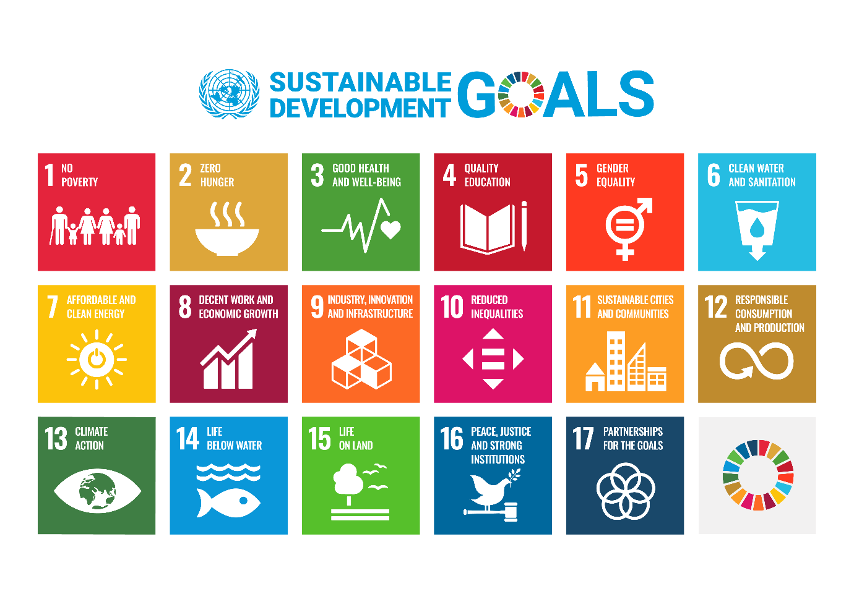
In 2015, the UK Government joined every other country in the world and committed to the United Nations Sustainable Development Goals (SDGs). The SDGs provide a holistic framework to eradicate poverty, reduce inequalities, combat catastrophic climate change, and protect our natural environment by 2030. Yet with just six years to go, and already halfway through the 2030 Agenda, the UK is far from achieving the SDGs. The SDGs and their targets provide an essential mechanism by which actions, outputs and change can be focussed and measured.
The SDGs are not a ‘nice to have, woke, green agenda’ – they provide the driver for government policy, for political action and the measures by which we can understand our progress and our priorities. No one can argue with the desirability of each of the 17 SDGs and of securing progress in each of the areas they represent. They should be the bedrock upon which the devolution of the Greater Lincolnshire is founded.
If not now, when?
If not you, me, us then who?
In our view there is a great deal to do if the devolved Greater Lincolnshire and the new Mayor are to deliver real progress.
The UNA-GL wishes to offer its resources to work with the new Mayor and the new Greater Lincolnshire in an advisory/mentoring capacity to meet the challenges we face.

Clive Wilson
Chair UNA GL

This reply to the consultation was approved by the Trustees of UNA GL.
We are thankful for the significant contribution made by John Firth, Honorary Professor, University of Liverpool, Department of Civil and Environmental Engineering, a member of UNA GL, in shaping this response.

https://www.unagreaterlincolnshire.org/media/trkdug0v/una-gl-response-to-devolution-lincs-and-rutland.docx

