UNA GREATER LINCOLNSHIRE
Education for Sustainable Development (ESD) and UN2030 SDG

Audit Tool for Secondary School
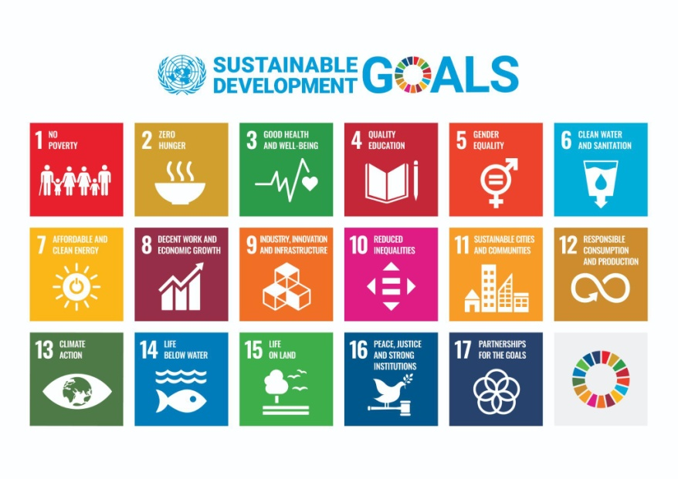
An audit and development planning tool to identify how ESD can be incorporated into Whole School Organisation and Provision.

This document contains hypertext web links e.g UNA Greater Lincolnshire, use Ctrl+Click to follow link.

FOREWORD
This audit tool has been developed by created by UNA Greater Lincolnshire. It is in response to the identified need to provide a straightforward approach for Secondary School staff.

Education for Sustainable Development is defined by UNESCO as:

“[empowering] learners with knowledge, skills, values and attitudes to take informed decisions and make responsible actions for environmental integrity, economic viability and a just society.

Education for Sustainable Development is a lifelong learning process and is an integral part of quality education.”

Many schools have started on the journey to establish Education for Sustainable Development as central to their purpose. However there are many who are starting out. This approach is designed to set them on their journey. There are many challenges facing secondary students in 2022, and many share concerns around their future and their wellbeing, Engaging in Education for Sustainable Development not only informs students of the challenges, but in so doing offers them the opportunity to gain agency in their lives and mastery of their likely future circumstances in work and life.

This tool is based on the United Nations’ Sustainable Development Goals.

The Goals are a universal call to action to end poverty, protect the planet and improve the lives and prospects of everyone, everywhere by 2030. The goals are interconnected and address the global challenges we face and identify the steps and actions needed to achieve them.

“For the goals to be reached, everyone needs to do their part: governments, the private sector, civil society and people like you.”
United Nations, 2015

Click Here Find out more about the United Nations’ Sustainable Development Goals.

ABOUT THE AUDIT TOOL

Audience
This audit tool has been developed for Secondary Staff and Students. As schools embrace greater democratic dialogue about their organisation and purpose with regard to sustainability, it is important to engage all stakeholders in developmental dialogues.

Purpose
The UN 2030 Sustainable Development Goals were created via extensive international discussion and agreement. Although they are stated as 17 discrete elements they are all linked. E.g. How can you have action on Climate if there is poor governance, how do you stop future hunger and poverty unless there is action on climate and good jobs for all. The approach starts with an overall view of Organisation and Management and then works out to ‘curriculum’ in its widest sense. As part of the Organisation and Management discussion external stakeholders including suppliers are a key element in establishing the foundations of credence for sustainability.

In using this audit, all will become more aware of the UN 2030 Sustainable Development Goals. It will enable all who have a responsibility for supporting learning to further develop their knowledge, understanding, attitudes and skills, and be empowered to make informed decisions and take responsible actions to promote environmental integrity, economic viability and a just society.

Structure of the audit tool
There are two parts to the Audit Tool
Part 1 Looks at the overall Governance and Management for ESD
- What is the Governance for ESD
- What Policies define ESD in organisation and operation, including estates and supply chain stakeholders
- What review and reporting arrangements are there for ESD

Part 2 Looks at the ‘Curriculum’ and Activities Undertaken by Students
For each SDG, there is:
- a short description and link to further information specific to the goal
- an area in which to record what you already do in relation to the goal, where we are now
- and area to consider where we want to be
- an area in which you can record what you can do to enhance or develop this area in the provision
The goals are interconnected, some activity in one area will give evidence for what you already do and ideas for future developments.

Starting points

Step 1: Learning about the goals and talk about them with others
Familiarise yourself with the UN 2030 Sustainable Development Goals.
Here are some web links.

Organisation | WEB ADDRESS
United Nations’ Sustainable Development Goals | https://www.un.org/sustainabledevelopment/sustainable-development-goals/
Act Now Individual Action | https://www.un.org/en/actnow
The App for living Sustainably | https://actnow.aworld.org/
WBCSD The Good Life Goals | https://sdghub.com/goodlifegoals/  https://sdghub.com/
UN SDG Planning Calendar | https://www.un.org/sustainabledevelopment/sdg-planning-calendar/
UNA Greater Lincolnshire | https://www.unagreaterlincolnshire.org/
Humberston Eco Centre | http://humberston-ecc.org/
Education and Training Foundation | https://www.et-foundation.co.uk/supporting/education-for-sustainable-development/
Sustainability and Environmental Education | https://se-ed.co.uk/

Step 2: identifying where we are now in Governance and ‘Curriculum’
Reflect on your Governance and ‘Curriculum’ and identify what you already do in relation to ESD and the goals. As the goals are interconnected, you may find you are doing something that addresses more than one goal.

Step 3: State where you want to be in the next period: Outcomes
Consider what can be achieved over the next 2 years in both Organisation and ‘Curriculum’. Build on existing good practice and state agreed, realistic, understandable and measureable Outcomes

Step 4 : Action Planning
State what you will do to achieve these outcomes. Some will be soft outcomes e.g. attitudes, some will be hard outcomes e.g. green energy supply. Build in public celebration points. Here is an example for goal 3, Good Health and Well-Being:

Goals | What do we already do?  Where we are. | Where we want to be | How we will get there
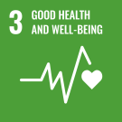 | 3 Good Health and Well-Being  Ensure healthy lives and promote well-being for all at all ages. | - Support for all health needs of students by designated staff  - Discrete modules on health at all levels within PSD  - Work with families on healthy lifestyles  - Work with community partners on health projects  - Support for careers education in health | - Engagement with families on diet and food chain and how to grow your own food  - Good provision of information on careers in healthcare  - Working with local organisations as partners to develop student skills in enterprise running an allotment and selling products  - Supporting a primary school in Africa to provide meals for its children | - Raise awareness in family consultations and parents group  - Visits from healthcare professionals arranged  - Establish a Link with Humberston ECO Centre  - Investigate a link with Africa School around sustainable development  https://internationalschooltoschoolpartnerships.org/

Step five: developing a plan of action
Use the action plan to identify the actions you will take to highlight and develop education for sustainable development opportunities for learners.

UN 2030 SDG Audit For Institution
Completed by |  | Completion date
Course(s) |  | Review date

Goals | What do we already do?  Where we are. | Where we want to be | How we will get there
Governance
Policies and procedures
Reviewing and reporting arrangements

NB: For organisations a consideration of the extent to which the policies and procedures are in tune with ‘circular economy’ and ‘doughnut economics’ concepts and principles is a good starting point for reflection.

Circular Economy : https://ellenmacarthurfoundation.org/topics/circular-economy-introduction/overview

Doughnut Economics: https://www.kateraworth.com/doughnut/

ACTIONS WITH STUDENTS

UN 2030 SD Goals |  | What do we already do?  Where we are now | Where we want to be | How we will get there
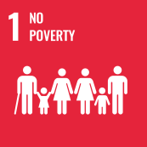 | 1 No Poverty  Ensure everyone has access to food, shelter clothing, healthcare and education so they can fully participate in society.
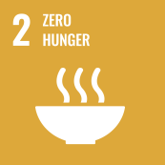 | 2 Zero Hunger  Address poor agricultural practices, food waste and environment degradation to ensure no one goes hungry.
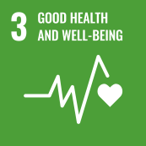 | 3 Good Health and Well-Being  Ensure healthy lives and promote well-being for all at all ages.
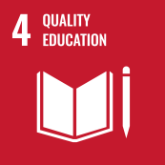 | 4 Quality Education  Ensure inclusive and quality education for all and promote lifelong learning for everyone, no matter who they are or where they are.
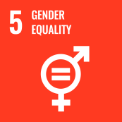 | 5 Gender Equality  Ensure equal access to education, health care and decent work for women and girls. End discrimination and violence against women and girls everywhere.
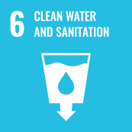 | 6 Clean Water and Sanitation  Ensure access to clean water and toilets for everyone. Value, protect and restore sources of water.
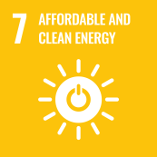 | 7 Affordable and Clean Energy  Enable everyone to access affordable, reliable, sustainable and modern energy that is clean and renewable.
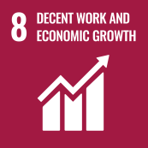 | 8 Decent Work and Economic Growth  Promote inclusive and sustainable economic growth and create employment opportunities and decent work for all.
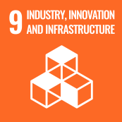 | 9 Industry, Innovation and Infrastructure  Encourage industries that bring opportunities to everyone while protecting the environment, supported by resilient infrastructure such as reliable transport and technological innovation.
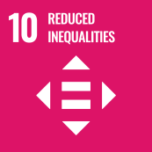 | 10 Reduced Inequalities  Reduce inequalities between rich and poor people and countries and make sure that everyone everywhere has a chance to live a healthy and happy life.
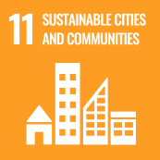 | 11 Sustainable Cities and Communities  Ensure cities and communities are clean, safe and sustainable, with good housing and services, as well as clean transport systems and green spaces for everyone.
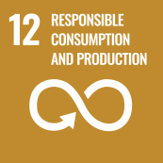 | 12 Responsible Consumption and Production  Encourage individuals, companies and governments to think about the things we produce and use and the waste we create in order to take more sustainable actions and reduce the impact on the planet.
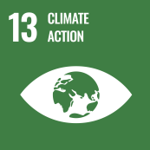 | 13 Climate Action  Take urgent action to combat climate change and change its impact.
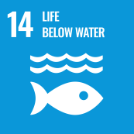 | 14 Life Below Water  Conserve and sustainably use the oceans, seas and marine resources.
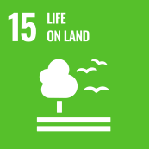 | 15 Life on Land  Stop activities that threaten our global home, including deforestation, land degradation and loss of animal and plant species.
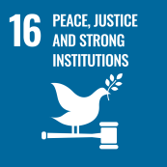 | 16 Peace, Justice and Strong Institutions  Ensure that everyone can live in a peaceful society, where they can have access to justice and don’t have to live in fear. Encourage everyone to participate in the public life of their countries.
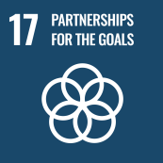 | 17 Partnerships for the Goals  Encourage governments, the private sector, civil society and individuals to work together to reach the goals.

ACTION PLAN
Use this action plan to identify the actions you will take to highlight and develop education for sustainable development opportunities for learners.

Action | Outcome and SDG | By who | By when | Expected impact | Review and reflections
Train staff and Governors on UN 2030 SDG and ESD | Awareness of all UN2030 SDG and ESD | Head and Consultant |  | Raised understanding and awareness of SDG and ESD, and importance in education and ability to influence change in the school

